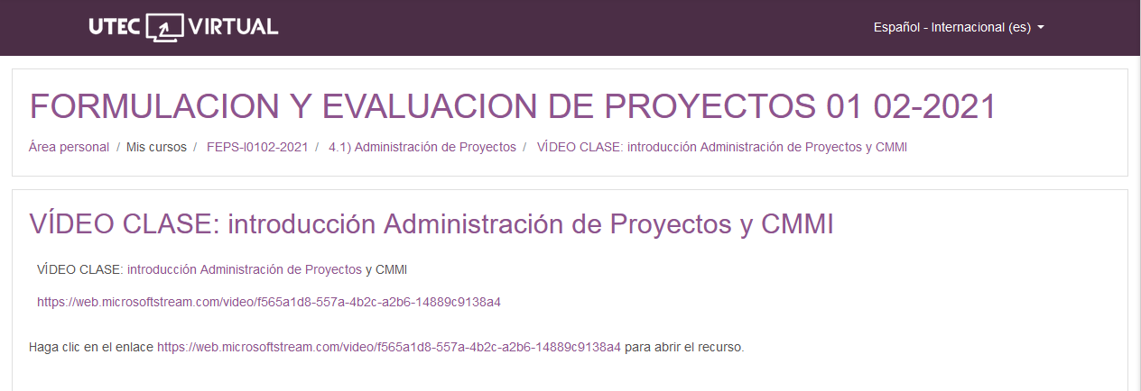

<https://web.microsoftstream.com/video/f565a1d8-557a-4b2c-a2b6-14889c9138a4>